How to update firmware of Smart Devices in Beli App

The firmware on Tenda smart devices can only be updated by using the Tenda Beli App. Please make sure you’ve downloaded this app before continuing.

Step1: Open the Beli app, click the device you want to adjust.

Step2: Tap the “three dots” icon on the top right corner.

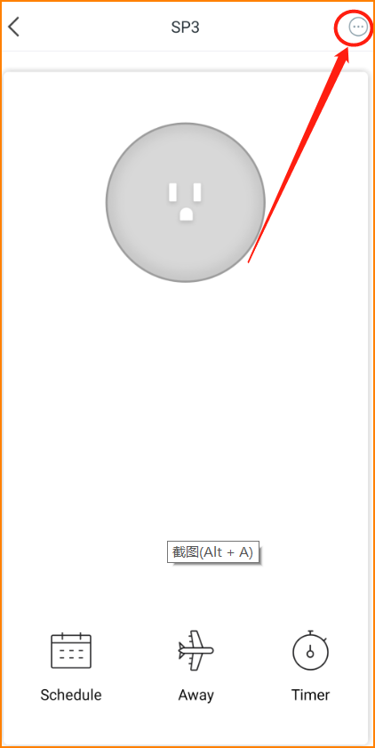

Step3: Slide down to the button, then click “check the firmware”.
Step4: This page will show you if there is a new firmware version. If there is, click “Upgrade now” and wait for a while, then the work is done.

